Name: Mohd Amirul Shafiq Bin Shafiee

Matric No: WQD180114

Milestone 2: **Management of Data Store Data Into Hive Data Warehouse**

**Step 1 – Create a directory**

* Create directory in HDF, which we will call ‘milestone2’
* Check if the directory exists

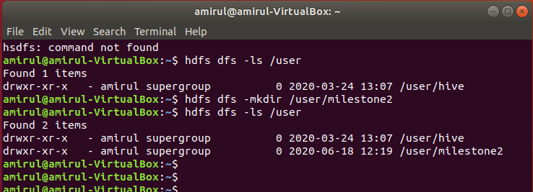

**Step 2 – Import Data**

* The data (df2) is on desktop. Import it to HDFS directory created earlier (milestone2)
* Check if data is successfully imported

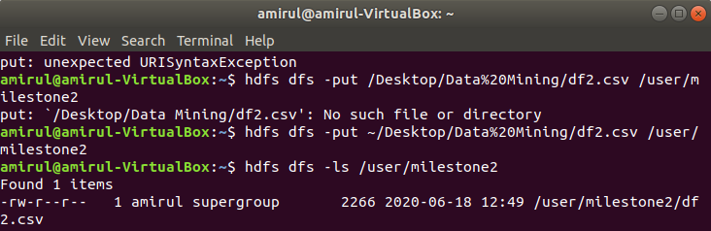

**Step 3 – Check the Data**

* Read the head of the data

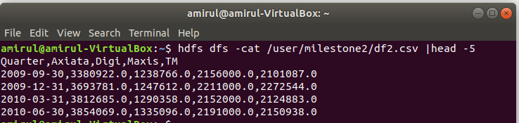

**Step 4 – Create table in Hive**

* Use query to create table with 5 columns and define the data type
* Remove first row as it is the column names

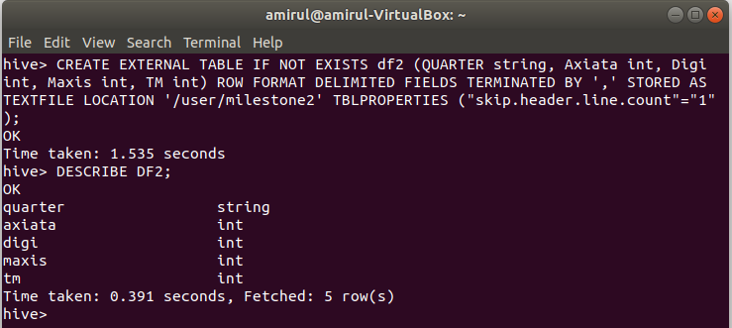

**Step 5 – Select all data in DF2 in HIVE**

